

|  |
| --- |
| **MATHEMATICS DEPARTMENT**  **Year 12 Methods - Test Number 3 - 2016  Integration and the Binomial Distribution**  **SOLUTIONS** |

1 The statement  is not correct since .

∴ C [2 marks]

2 The width of each rectangle is 0.2 and the centres are at 0.1, 0.3, 0.5, …, 0.9

The heights are f(0.1), f(0.3), f(0.5), …, f(1.9)

Total area = 0.2 × 0.13 + 0.2 × 0.33 + 0.2 × 0.53 + 0.2 × 0.73 + 0.2 × 0.93 + 0.2 × 1.13   
  + 0.2 × 1.33 + 0.2 × 1.53 + 0.2 × 1.73 + 0.2 × 1.93

= 0.2 ×[0.13 + 0.33 + 0.53 + 0.73 + 0.93 + 1.13 + 1.33 + 1.53 + 1.73 + 1.93]

∴ D [2 marks]

3 The algebraic area between x = – 4 and x = 1 is negative, so  will give the physical area.

∴ E [2 marks]

4 Width of each rectangle is 0.5 units.

Heights are f (0), f (0.5), f (1), f (1.5)

i.e. 4 – 02, 4 – 0.52, 4 – 12, 4 – 1.52

Total area = 0.5 × (4 – 02) + 0.5 × (4 – 0.52) + 0.5 × (4 – 12) + 0.5 × (4 – 1.52)

= 0.5 × [4 – 02 + 4 – 0.52 + 4 – 12 + 4 – 1.52

∴ A [2 marks]

5 

= – cos – [– cos(0)]

= –  + 1

= 

= 

∴ B [2 marks]

6  = 

= = 

∴ D [2 marks]

7 Area between x = 0 and x = 5 is 

Area between x = 5 and x = 8 is  total area = 

∴ C [2 marks]

8  = 

= 

= 

= 

= 4 × 23 − 8

= 24

∴ D [2 marks]

9  = 2(x − 3) 

So  = 

So  = 

= 

∴ E [2 marks]

10 This is a binomial experiment with p = , q = , n = 4 and x = 2.

P(X = 2) = 

[3 marks]

**Resource Rich Section**

1 Let X be the number of prisoners who reoffend.

n = 10

p = 0.68

P(X = x) =  (0.68)x(0.32)10 − x [1 mark]

P(X ≥ 4) = 1 – P(X < 4)

= 1 – [P(X = 0) + P(X = 1) + P(X = 2) + P(X = 3)] [1 mark]

= 1 – (0.32)10 +  (0.68)1(0.32)9 +  (0.68)2(0.32)8 +    
 [1 mark]

≈ 1 – (0.000 011 + 0.000 239 + 0.002 288 + 0.012 965)

= 0.9845 [1 mark]

2 a For any binomial experiment P(X = x) =  p qn − x

For this binomial experiment P(X = x) =  (0.45)x(0.55)6 − x

n = 6 [1 mark]

b p = 0.45 [2 marks]

c P(X = 0) = (0.45)0(0.55)6 ≈ 0.0277

P(X = 1) = (0.45)1(0.55)5 ≈ 0.1359

P(X = 2) = (0.45)2(0.55)4 ≈ 0.2780

And so on.

|  |  |  |  |  |  |  |  |
| --- | --- | --- | --- | --- | --- | --- | --- |
| *x* | 0 | 1 | 2 | 3 | 4 | 5 | 6 |
| *p(x)* | 0.0277 | 0.1359 | 0.2780 | 0.3032 | 0.1861 | 0.0609 | 0.0083 |

[3 marks]

3 a This is an example of a binomial experiment.

n = 7

p = 0.25, q = 0.75

X = number of bullseyes

P(at least 2 bullseyes) = P(X ≥ 2)

= 1 – P(X < 2) [1 mark]

= 1 – [P(X = 1) + P(X = 0)]

= 1 – (0.25)1(0.75)6 – (0.75)7

= 1 – 0.3134… – 0.1314…

≈ 0.5551 [1 mark]

b n = ?

p = 0.25, q = 0.75

X = number of bullseyes

P(X ≥ 1) > 0.9

P(X = 1) + P(X = 2) + P(X = 3) + … > 0.9

1 – P(X = 0) > 0.9 [1 mark]

1 – (0.75)n > 0.9

–(0.75)n > 0.9 – 1

(0.75)n < –0.9 + 1

(0.75)n < 0.1

n > 8.0039… (using a graphics calculator or trial and error) [1 mark]

The archer must take at least 9 shots to ensure the probability of scoring at least one bullseye is at   
least 0.9. [1 mark]

4 a  [1 mark]

= (32 – 9 × 3) – (12 – 9 × 1) [1 mark]

= 9 – 27 – 1 + 9

= – 10 [1 mark]

b  [1 mark]

= e6 – e2 [1 mark]

= e2(e4 – 1) [1 mark]

c  [1 mark]

= sin(π) – sin(0) [1 mark]

= 0 – 0

= 0 [1 mark]

d  [1 mark]

 [1 mark]





= 22  [1 mark]

5 a 

 [1 mark]



= 0 [1 mark]

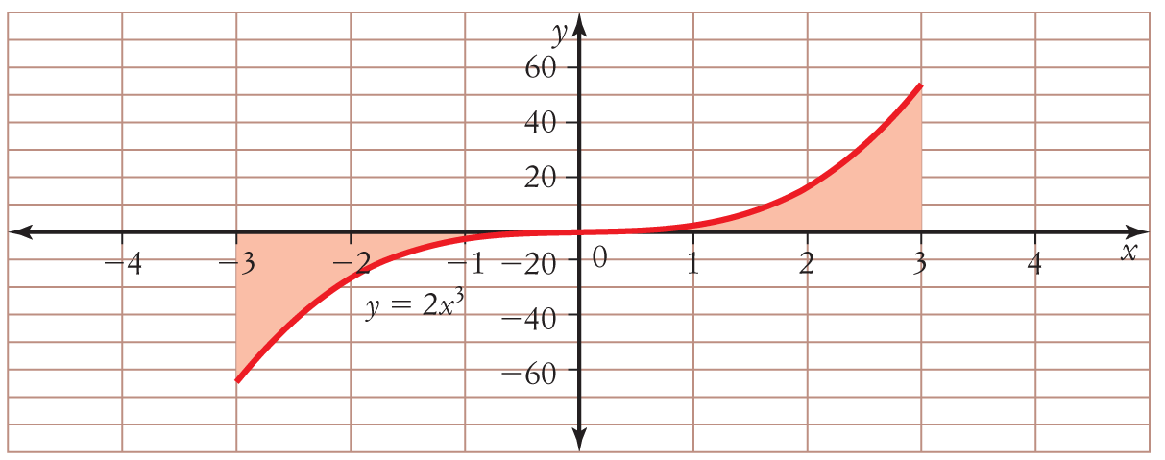b

 [1 mark]





 [1 mark]

= 34 – 04

= 81

The area is 81 units2. [2 marks]

6 

 [1 mark]

 [1 mark]

= (14 + 13 +  – 6 × 1) – (04 + 03 +  – 6 × 0)

= 1 + 1 +  – 6 – 0

= – 3 [1 mark]

7 a = 

=  [1 mark]

=  − 

= 69 − 1

= 68 [1 mark]

b  = 

=  [1 mark]

= 2 sin(π) − 2 sin(−π)

= 0 − 0

= 0 [1 mark]

c  = 

= 

=  [1 mark]

= 

=  [1 mark]

8  = 8x − 7

y = 4x2 − 7x + c [1 mark]

y = 13 when x = −1, so 13 = 4 × (−1)2 − 7 × −1 + c

13 = 11 + c

c = 2 [1 mark]

y = 4x2 − 7x + 2 [1 mark]

9 Draw a sketch of y = x2 − 4x − 12.

Identify the key features.

The graph is a parabola.

Let y = 0, x2 − 4x − 12 = 0

(x + 2)(x − 6) = 0

x = −2 or 6 [1 mark]

Zeros are located at (−2, 0) and (6, 0).

The function has a minimum.

Find the derivative: y′ = 2x − 4

Let y′ = 0:   0 = 2x − 4

x = 2

When x = 2: y = −16 [1 mark]

Minimum at (2, −16)

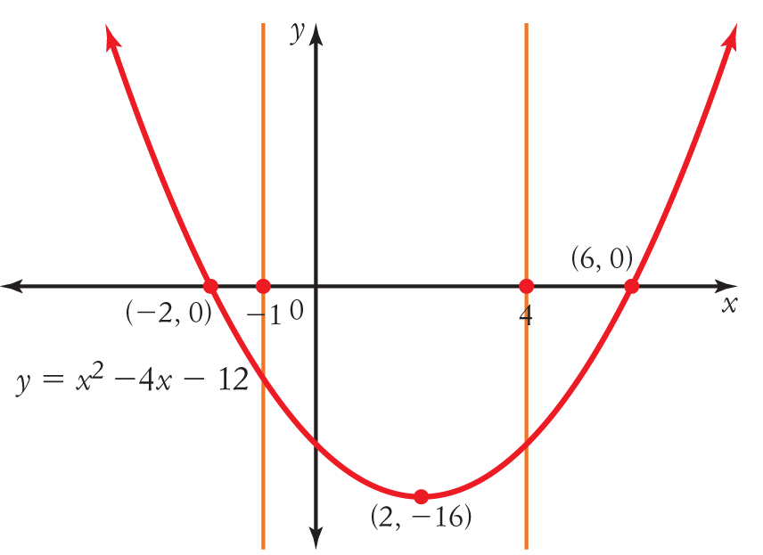

Required area = 

= 

= 

=  [1 mark]

= 

= 

= −68 

The negative sign means the area is below the x-axis.

Area = 68units2 [1 mark]

10 Total change =  [1 mark]

=  [1 mark]

= 381.…

In the first 3 hours, about 381 L flowed into the tank. [2 marks]